

**UNIVERSITY OF PETROLEUM AND ENERGY STUDIES**

**School of Computer** **Science**

**2020-21**

**GRAPHICS AND ANIMATION TOOLS LAB**

**Faculty: Dr. DURGANSH SHARMA**

**Assistant Professor**

**Department of Cybernetics.**

**School of Computer Science, UPES**

**Submitted By:**

**Name- Garima Dhall**

**Roll no-R100217025**

**Batch-B1**

**Semester- 7**

**Course-B.tech. CSE-OSOS**

**Sap Id- 500062498**

**EXPERIMENT NO 5**

**Aim** :- Design of 3D Hut using Blender.

**Objective** :- To Design a 3D Hut using features of Blender 2.8 .

**STEPS TO MAKE DESIGN A 3D Hut:-**

1. Open Blender workspace delete the existing cube and Click on the add option and add cylinder and make its vertex 15 and radius 2 and choose option nothing

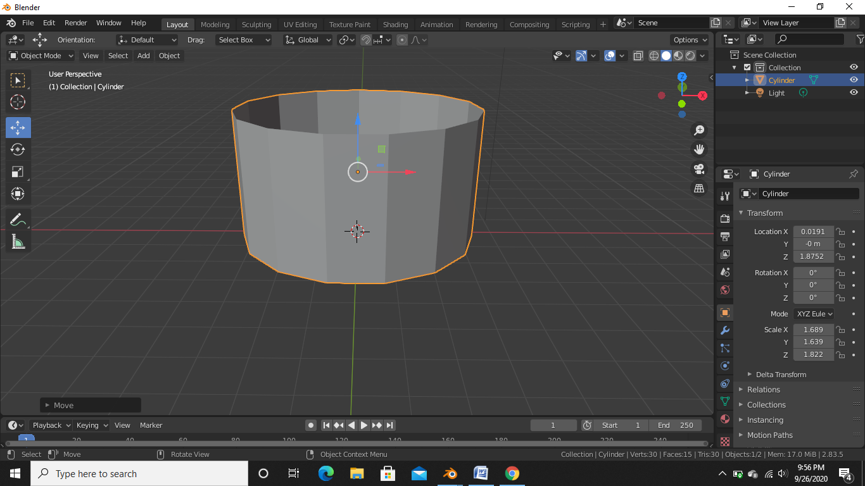

1. Then we will make some adjustments in the cylinder open the editor in edit mode and cut loop on cylinder top and bottom

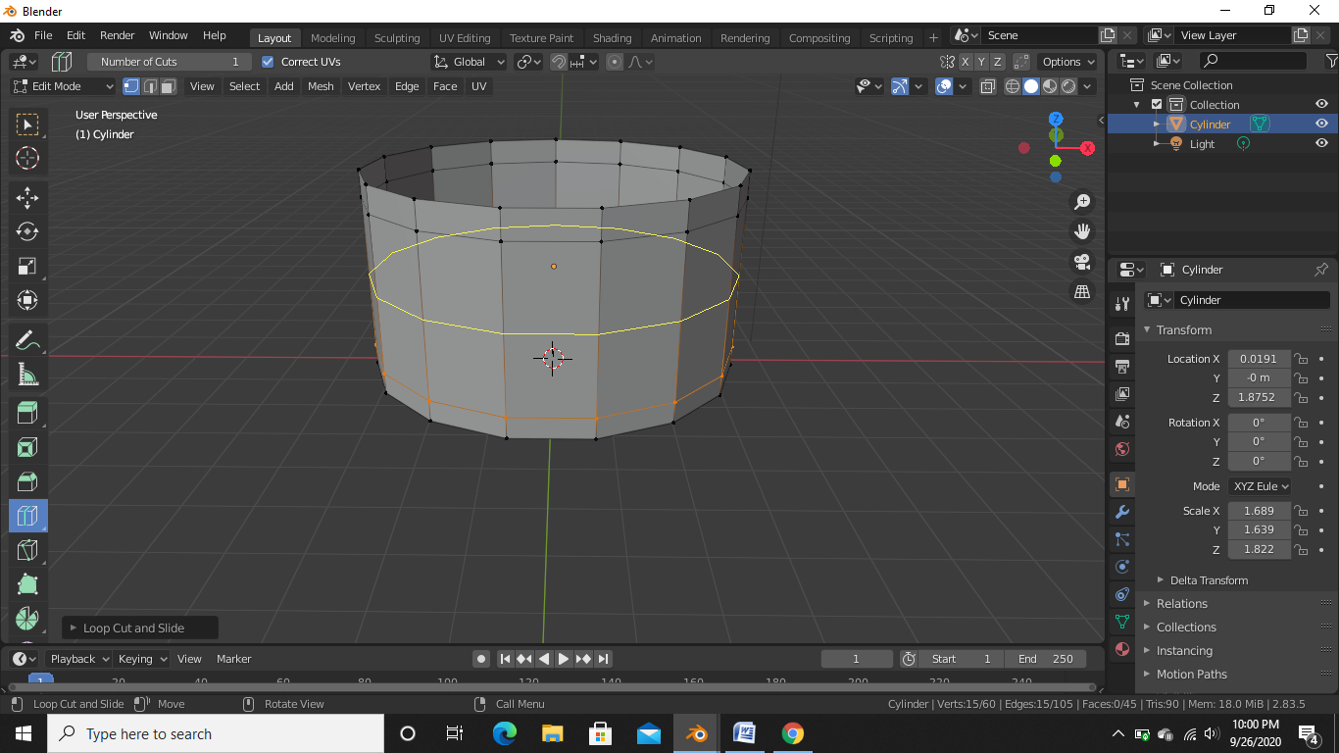

1. After making changes in the cylinder we will add the cube and adjust the cube into the cylinder so that it looks like a door we can do this by adding a modifier to the cylinder the modifier which we need to add to the cylinder is the Boolean and in edit mode we have to delete the faces of the cubes and doing that we have to apply modifier

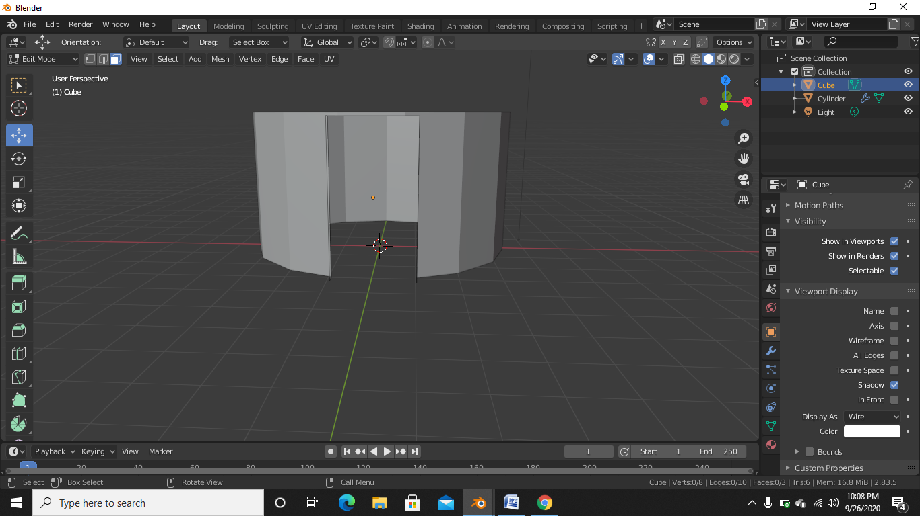

1. After the above step add the cone from the add option and adjust the cone in such a way that it looks like the roof of the hut

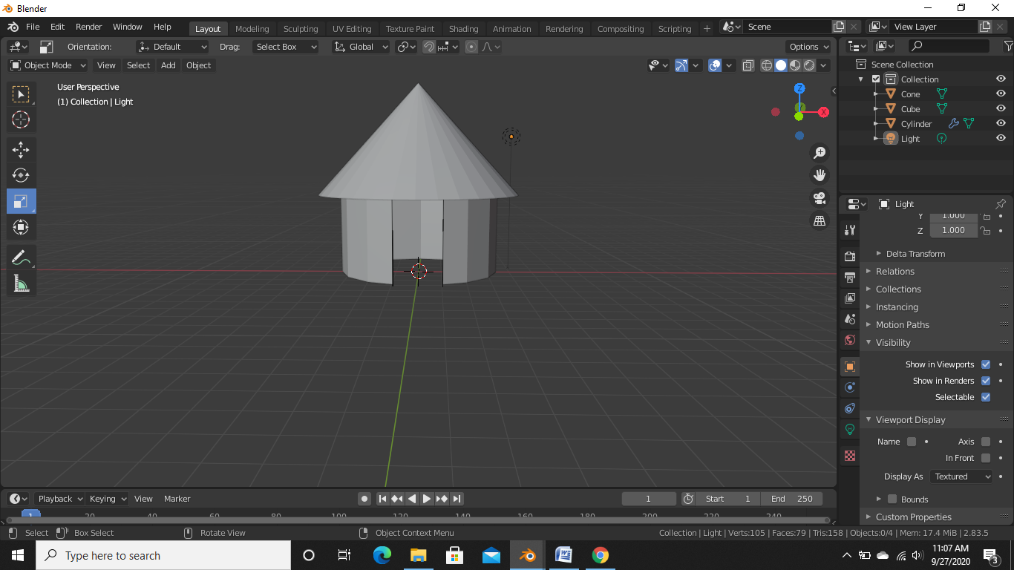

1. After the above step give the appropriate color to the base and the roof of the hut

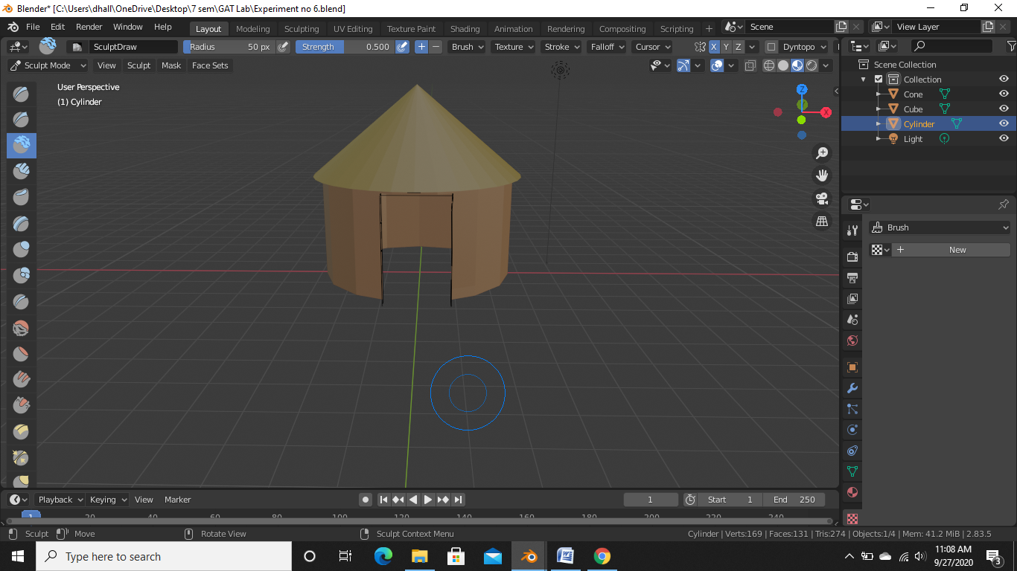

1. After giving the texture and the hut the final outcome will look like the below figure

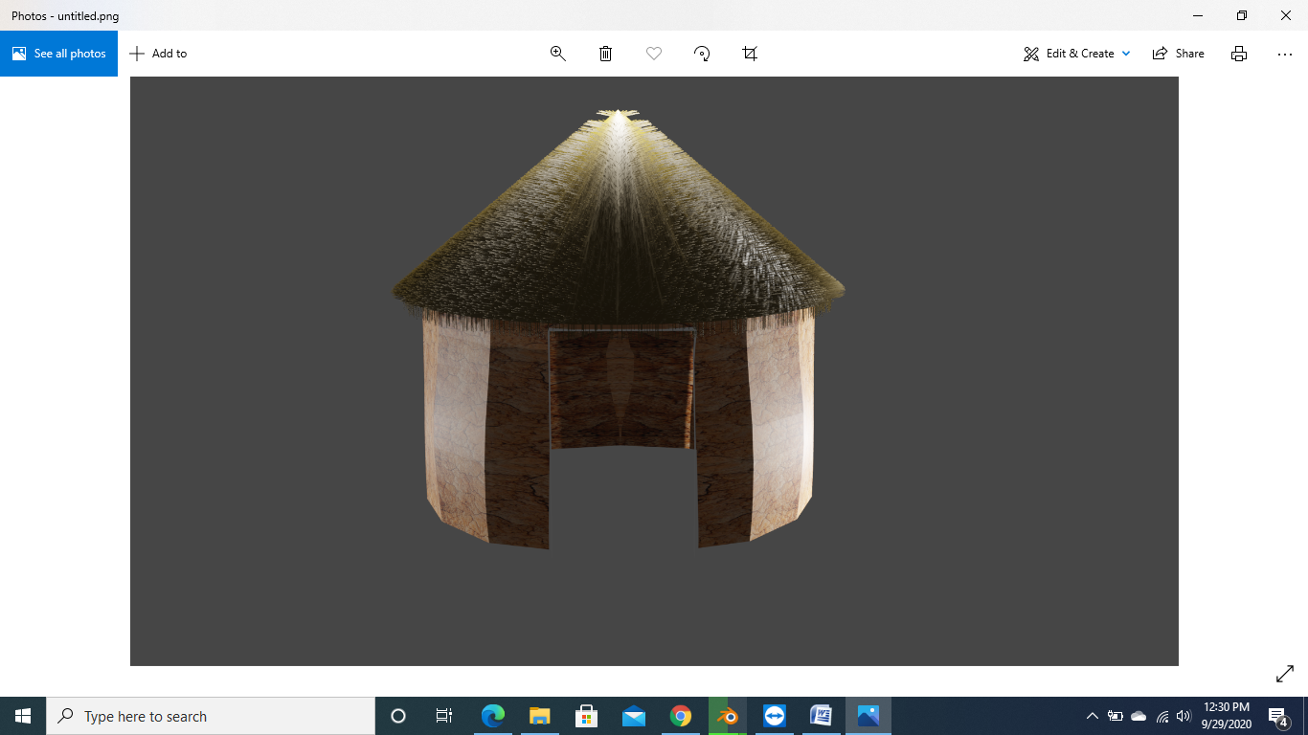

Link for the google drive :- <https://drive.google.com/drive/u/0/folders/1Juwze5P5Roy1sJciJ3lyPlmanmIBjWL->